**IQR (Inter Quartile Range):**

 IQR is the difference between the third and first quartiles (a.k.a. the 75th and 25th quantiles). IQR is often reported using the "five-number summary," which includes: minimum, first quartile, median, third quartile and maximum. Like mean and standard deviation, median and IQR measure the central tendency and spread, respectively, but are robust against outliers and non-normal data. Median absolute Deviation = Median (| x_i – median |) i=1 to n IQR (Interquartile Range) = Q3 – Q1. The difference between the 75th percentile and the 25th percentile.

**MAD (Median Absolute Deviation):**

 The median absolute deviation(MAD) is a robust measure of how spread out a set of data is. The variance and standard deviation are also measures of spread, but they are more affected by extremely high or extremely low values and non normality or outliers. If your data is normal, the standard deviation is usually the best choice for assessing spread. However, if your data isn’t normal, the MAD is one statistic you can use instead.

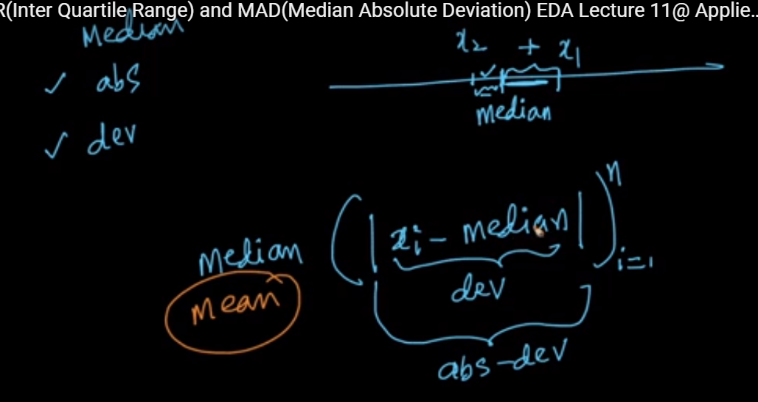

**Formula for Median Absolute Deviation:**

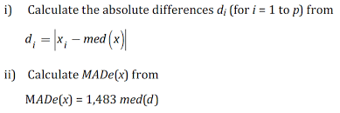

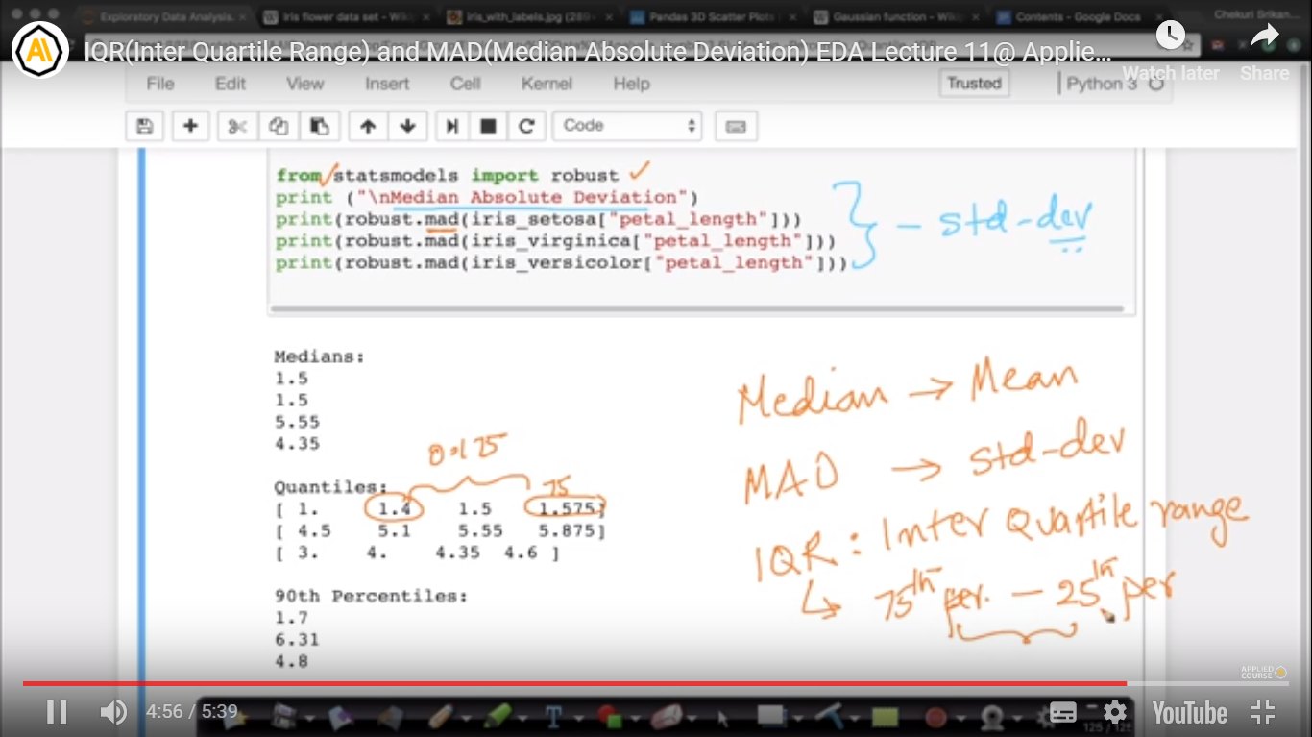

**Diff bef SD and MAD:**

Absolute deviations are less sensitive to extreme outliers (values far from the mean/trendline) compared to standard deviations because they don't square that distance before adding it to the values from other data points. The real reasons why SD is used more often is because the maths is easier to work with ... furthermore, it's easier computationally (both because medians require "sorting", and because squares are faster to compute than branch statements). Using absolute deviations reduces this distortion, but at the cost of making calculation of the trendline more complicated.